Supermarket Management System



Database class project 2020/2021

|  |  |  |  |  |
| --- | --- | --- | --- | --- |
| Student Name in English | Student Name in Arabic | Student ID | Section | Work percentage |
| Aseel Masri | أسيل نصر عبد الرحمن مصري | 11925458 |  | 50% |
| Tasneem abu alrob | تسنيم اياد يوسف أبو الرب | 11923952 |  | 50% |
|  |  |  |  |  |

Date/time

---------------------------------------------This section is intended for the Instructor---------------------------------------

|  |  |
| --- | --- |
| **Topic** | **Mark** |
| Project Requirements and Modeling |  |
| Correctness of Database mapping |  |
| Functional Dependency and Normalization |  |
| Project Tools |  |
| Project Discussion |  |
| Project Completeness |  |
| Project Output Results or reporting (Jasper Report, charts, graphs, etc.) |  |
| Project Administration and Management |  |
| Project Report |  |
| Project Idea |  |
| Project Complexity |  |
| Team work |  |
|  |  |
|  |  |
|  |  |

**Abstract**

In this project, we made an application that helps merchants and supermarket owners in organizing their products and information about their customers and their departments to facilitate transactions between the seller and the buyer by registering in it, using the NetBeans program for design and SQL developer program to create a database and store information in it and there are many features in this application like creating accounts on it ,adding, modifying ,deleting Product,Customer,Category and more than it, and we reached for this work using the course lectures and YouTube.

**TABLE OF CONTENTS**

**1.** Introduction 3

2. Project requirement 4

3. The functional dependency 5

4. Normalization 5

5. Project UML ………………………………………..7

6. Tools used in the project………....................8

7. Interfaces 9

8. Reports

9. Conclusion 24

10. Referance 24

**Introduction**

This application is intended for the seller and the buyer where they create accounts on it and then use it, through which the buyer chooses the appropriate products for him in terms of price and quantity, and this includes offers and discounts on the price and thus obtains a total invoice

As for the seller, through it he can create an easy environment to display his products, manage supermarket departments and all transactions of his customers.

We got the idea from the online shopping experience that became popular during the quarantine due to the Corona virus, so we thought of making an application that would make it easier for both the seller and the buyer.

The main target is to help merchants organize their products and manage their work environment in an electronic way that is easier and saves time, on the other hand, saving time and effort on the customer.

**Requirements**

* The project contains two types of users: Admin and customer, to create an admin’s account, you must choose the account type: as a admin. You are asked to enter your information, and if you want to create customer's account , you must choose the account type: as a customer. You are asked to enter your information.

* The database should be able to provide the personal information of the user to allow him to sign up such as full name, password, phone ,email, gender , country, security question and it's answer ,but if already he has an account he sign in with his username and password after choose his type.

* The supermarket has sections ,the section has unique name and description , each section managed by an admin but each admin can be manage many of section, section contains of categories and each category has unique name and Details about the products inside.

* Certainly there are products and products belong to category ,each of them have number, name, price, quantity and description , each product has bill that has number and quantity

*each customer order bill to select suitable products and to pay Products price.

*a bill can have an offer or not, an offer might include more than one bill, each offer has off_num, off_name , offer_date and discount.

* Each customer can update, add and delete his order.

* If the user is an admin, he has many permissions :he can add and delete customer, add and delete product , add order to customer and delete, update it .also he can add new category, remove or update.

* but if user is customer can only go to billing to select products and pay their cost.

**The Functional Dependency**

There are no functional dependencies in our project except that depend on the **primary key.**

Adminn Table: Admin_Num ــــــــــــــ> full name, password, phone ,email, gender , country, security question ,answer_question .

Bill Table: Bill_Num ــــــــــــــ> Quantity

Offer Table: Off _Num ــــــــــــــ> Discount, Offer_Date, Off_name

Product Table: Pro _Num ــــــــــــــ> Pro_name, Price, Description, pro_Quantity

Customer Table: Customer_Num ــــــــــــــ> full name, password, phone ,email, gender , country, security question ,answer_question .

Categoryy Table: Catg_Name ــــــــــــــ> Details

**Normalization**

Our project does not contain functional Dependencies , and what we will mention below is a check that all the tables that we created for our project are in BCNF , this is because all attributes depend on the primary key of the table

In All tables: 1NF: there is no Multiple attributes.

2NF: in 1NF and no composite key, or all attributes depend on composite key

3NF: in 2NF and no non-primary key column is transitively depends on the primary key , so to check BCNF.

**1-Admin Table :**

(adminn_num,Fname,Lname,Mname,gender,email,password,country,phone,security_question,answer_question)

Admin_Num ــــــــــــــ> full name, password, phone ,email, gender , country, security question ,answer_question

(Adminn_num : is primary Key(contains a candidate key of the relation ) SO **it's in BCNF**

**2-Customer Table :**

(Customer_num,Fname,Lname,Mname,gender,email,password,country,phone,security_question,answer_question)

Customer _Num ــــــــــــــ> full name, password, phone ,email, gender , country, security question ,answer_question

(Customer _num : is primary Key(contains a candidate key of the relation ) SO **it's in BCNF**

**3-Product Table :**

(Product_num, Pro_name, Price, Description , Catg_name,Pro_Quantity)

Product _Num ــــــــــــــ> Pro_name, Price, Description , Catg_name, Pro_Quantity

(Product _num : is primary Key(contains a candidate key of the relation ) SO **it's in BCNF**

**4-Offer Table :**

(Off_num, Off_name, Offer_Date, Descount )

Off _Num ــــــــــــــ> Off_name, Offer_Date, Descount

(Off _num : is primary Key(contains a candidate key of the relation ) SO  **it's in BCNF**

**5-Categoryy Table :**

(Catg_name, Details, Sec_Name )

Catg_name ــــــــــــــ> Details, Sec_Name

(Catg_name: is primary Key(contains a candidate key of the relation ) SO  **it's in BCNF**

**6-Section Table :**

(Sec_name, Description, Admin_num )

Sec_name ــــــــــــــ> Description, Admin_num

(Sec_name: is primary Key(contains a candidate key of the relation ) SO  **it's in BCNF**

**7-Bill Table :**

(Bill_num, Pro_num, Quantity )

Bill_num ــــــــــــــ> Pro_num, Quantity

(Bill_num: is primery Key(contains a candidate key of the relation ) SO  **it's in BCNF**

**8-OrderrTable :**

(Bill_num, Customer_num, Products_Price )

Bill_num, Customer_num ــــــــــــــ> Products_Price

(Bill_num, Customer_num: are primary Keys (contains a candidate key of the relation ) SO  **it's in BCNF**

**UML**

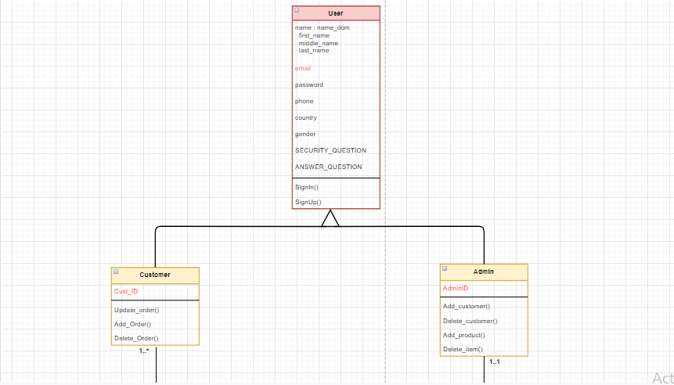

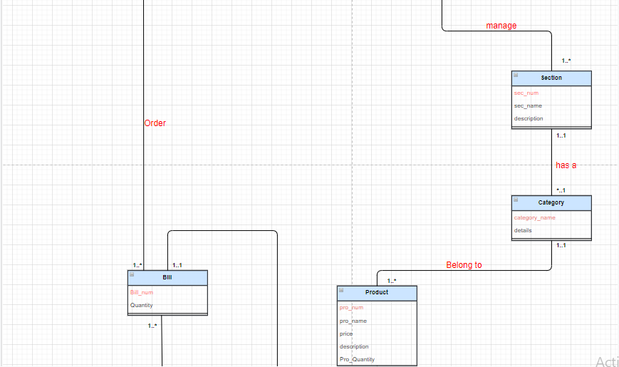

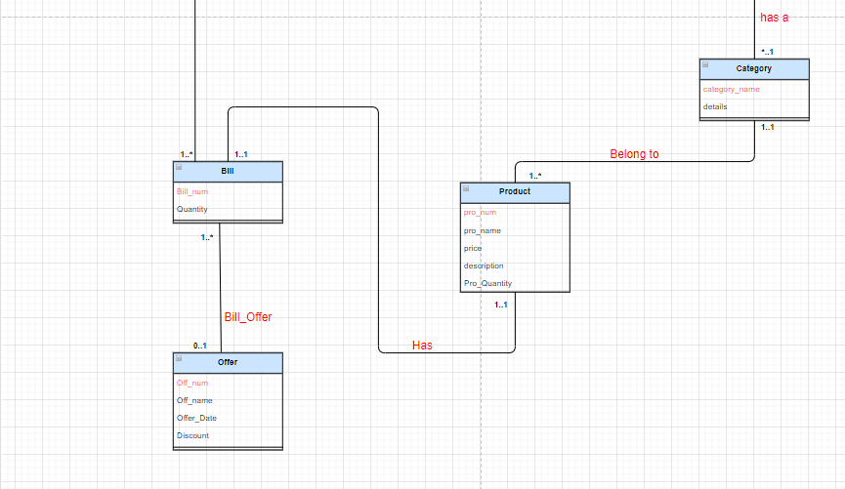

**Tools**

* Sql developer.
* NetBeans .
* jasper studio

**Interfaces**

The first page in our project is loading page , in this page the login page will be opened once the loading is complete.

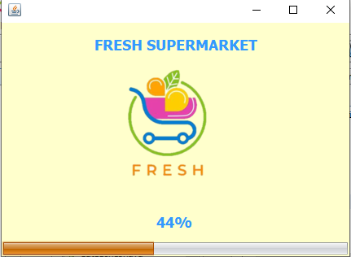

After login page is opened you must choose the role Admin or Customer , if the user id and password is matched then you will go to the next page , in case you don’t have an account you can create account by click sing up button , and if you forget your password click into forget password button to help you recover your account.

Note : you can show your password by click on show password checkbox and then you can see your password.

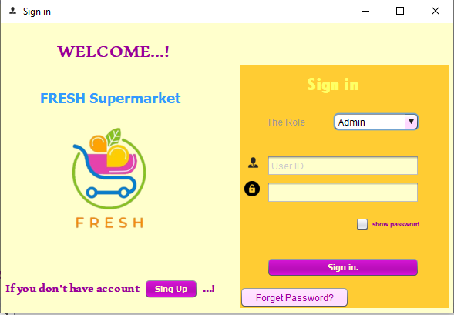

This page is sign up page that enables the customer to create an account if he/she don’t have it by filling this information.

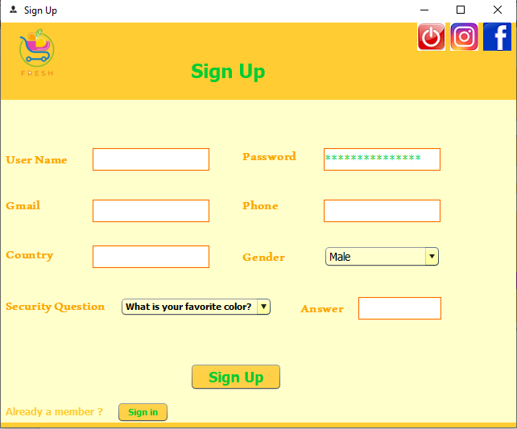

In this page , the user enter it when he/she forget her/his password , the user enter user number and then click to search to appear her/his own security question then user enter the answer of security question if the answer is correct then user can changing password otherwise he/she can not do it .

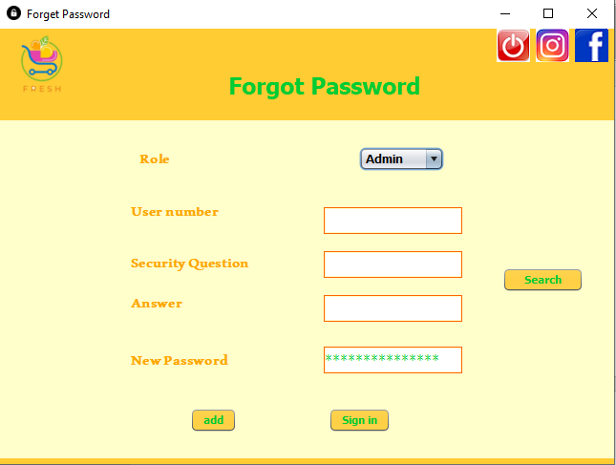

***Admin account***

After User log in as Admin this page appear , in this page you can display jasper reports by click one of two button (Generate report Or Generate chart) .

As noted, there is a menu on the left side when you click on one of its buttons then it will go to its next page according to the button you clicked on.

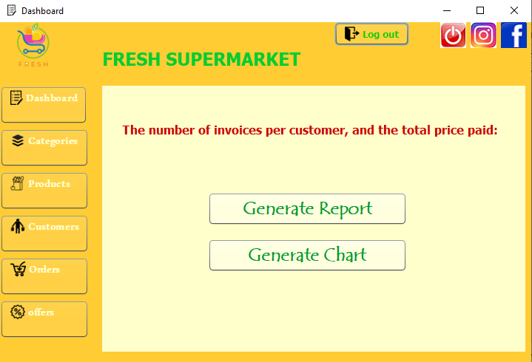

Admin can be search, add ,edit ,delete categories by this page, and if the operation is successful , the successful operation notification will appear.

By show button we can display all categories in the table .

If we double click on row table then this information on row will fill on jtextfield and jcombobox automatically (this property is available in all tables on project )

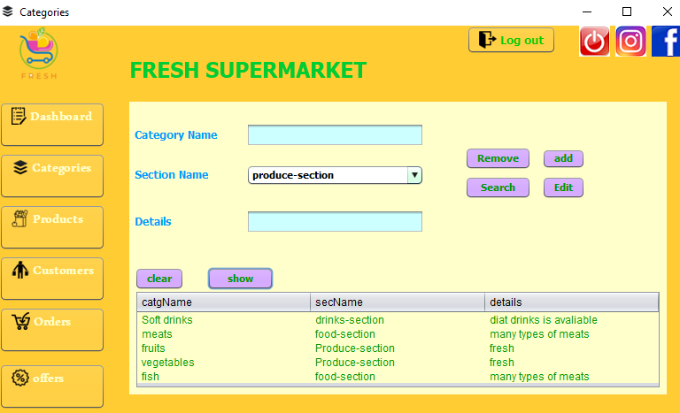

In the jframe below, add success notification.

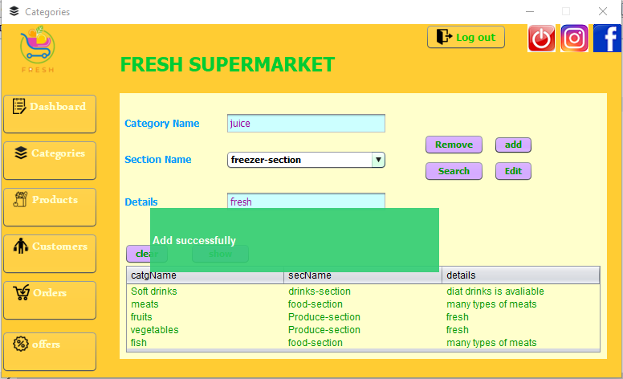

In this page ,Admin can add product that belong to certain category and set its price and other information , these products the customer will buy it and put it in her/his billing.

Admin can also edit, search or delete product .

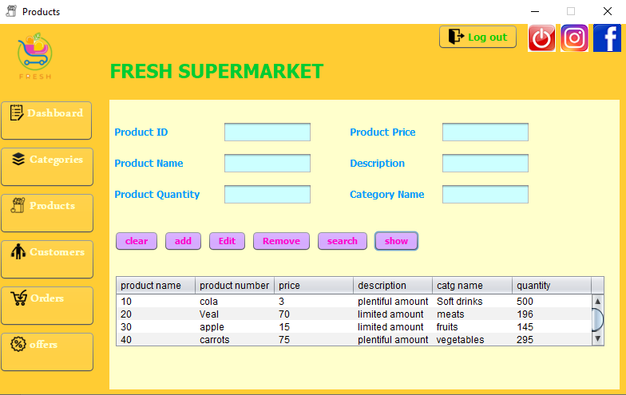

The admin also has the ability to add customers, delete customers , search customer, edit in customer’s information .

He is doing that by Customer interface.

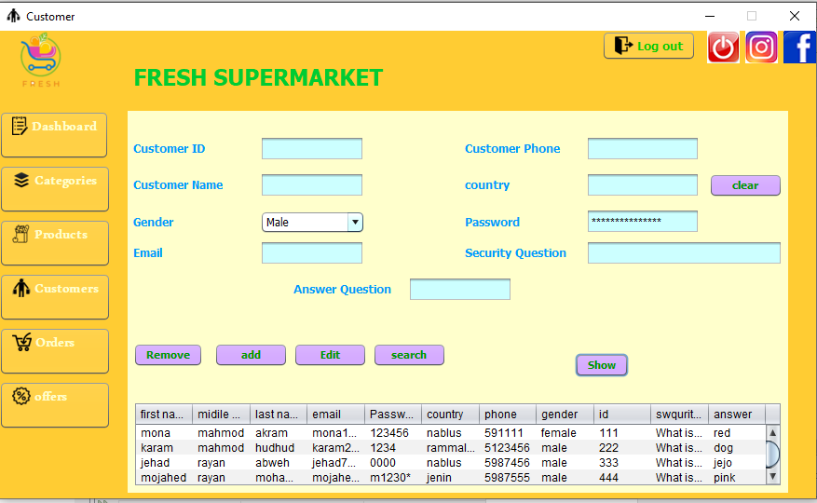

After customer buying product then all her/his billings add to order table ,

This table show all customer’s billing and total price for each bill.

We can find total number of billing for each customer by filling customer id jtextfeild and then click on number of customer bill button, and to find total price for each customer click on total price of billing .

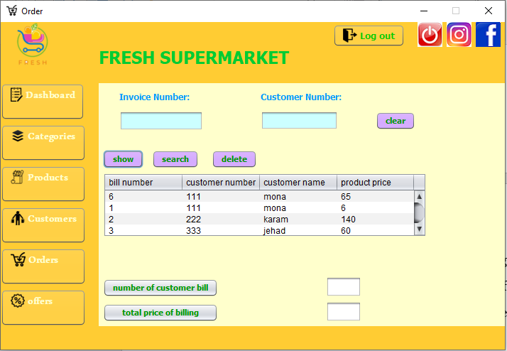

Also admin can add offer at a certain date if the customer buys products at the same date of offer he will get an offer discount for each customer’s bill.

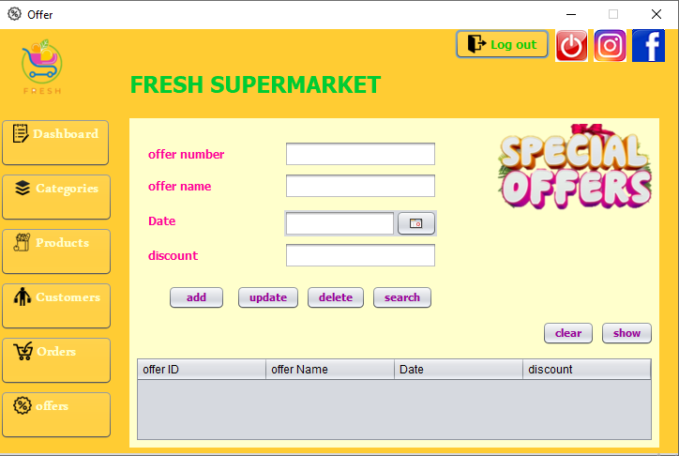

***Customer Acount***

After the customer sign in this page will be appear , in this page customer can buy many of product and set a certain amount of product and adding these products on the customer’s bill .

To add a product, you must first select the category it belongs to after click refresh and then click on the search button to show all the products that belong to this category and finally you can click on the table row for the product you want and then select the quantity and date.

If in this date supermarket have offer then there will be discount in customer’s bill.

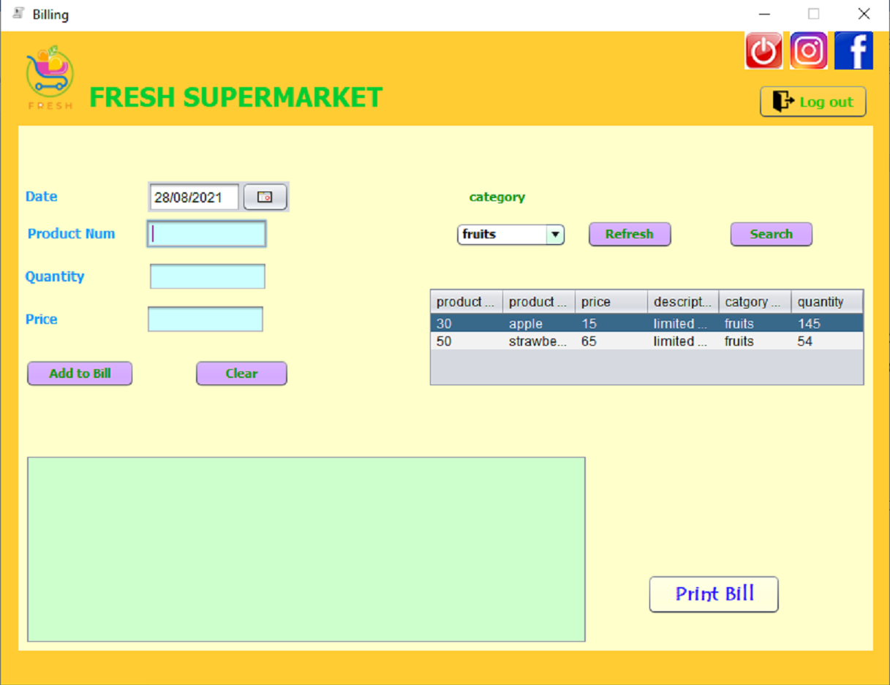

After the customer has finished purchasing the products, he can print his invoice by clicking on the print button.

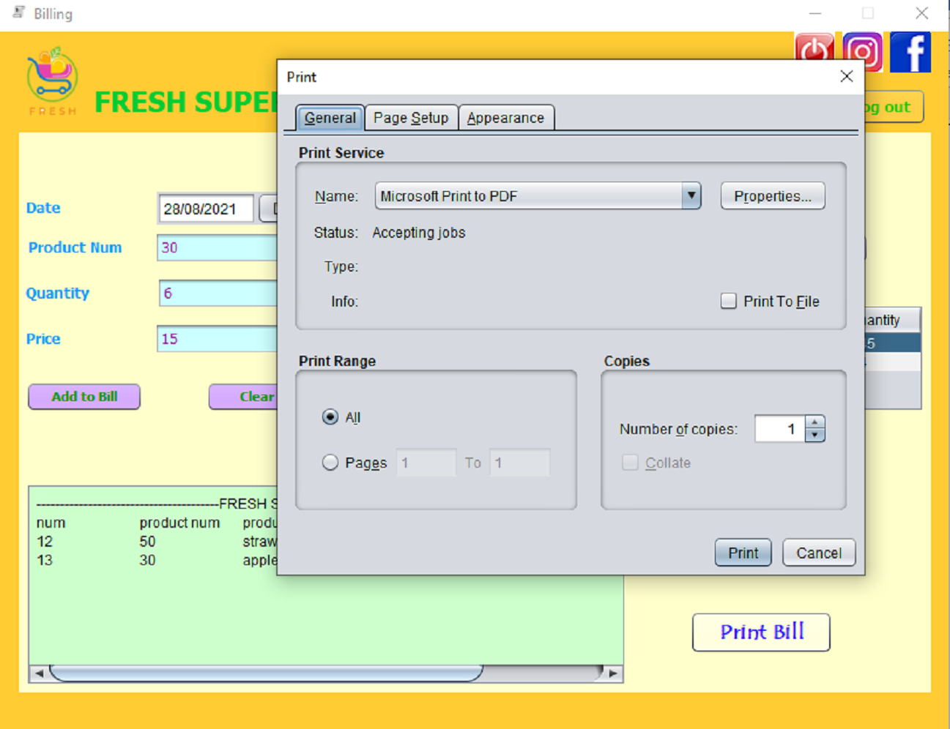

As noted in previous interfaces, this page is available to each of them.

If you click on exit icon the program will be exit.

If you click on the Facebook icon, you will be taken directly to the supermarket's Facebook page.

If you click on the Instagram icon, you will be taken directly to the supermarket's Instagram page.



***Facebook page:***

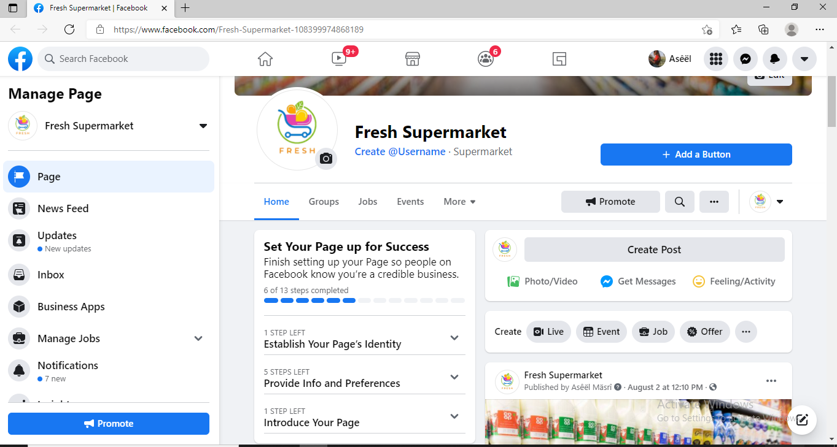

***Instagram page :***

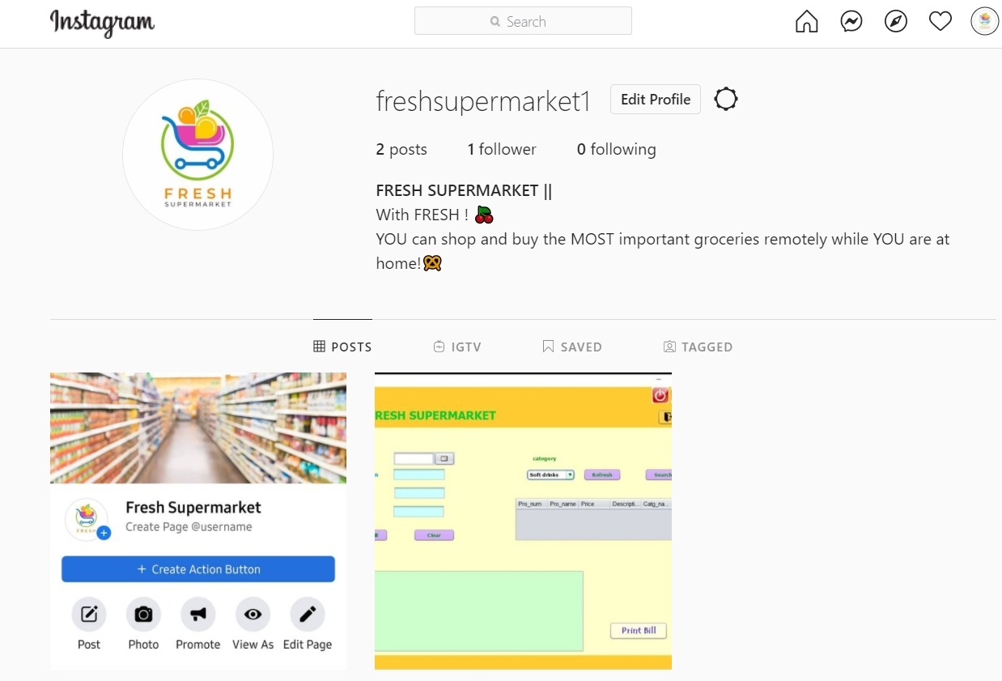

**Reports and Chart**

In our project we create report number of bill and total price for each customer.

Report :

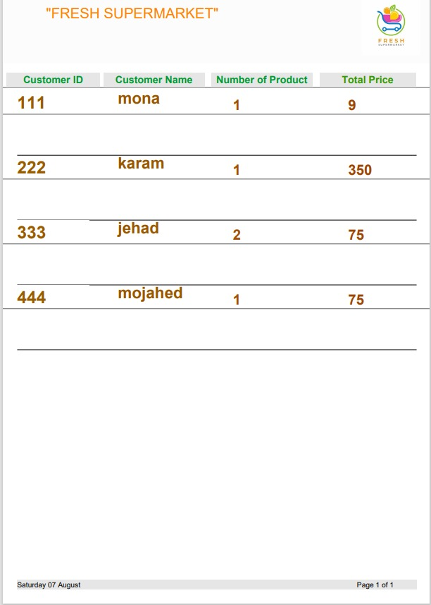

Chart :

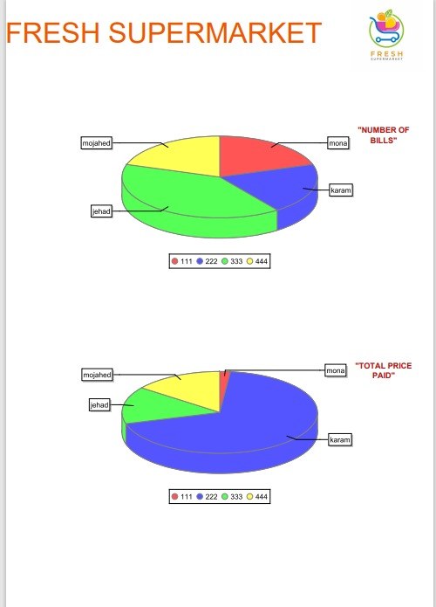

**Conclusion**

In the end, this project was tested on a small set of values, but that's not the end.

It was a great experience learning how to use the database and link it to other programs.

We will continue to work on it to develop our project and ensure that it is ready for use on a larger scale with more details, to serve the groups we targeted with this project to the fullest.

**References**

* Google.
* Lectures of this course..
* YouTube